Tiffany Ford
Tiffani Listenbee
Janet Vrba
Dr. Levy-7735
Coming of Age Writing Assignment Process

The rigorous turmoil of lost and found thoughts that require a teacher’s attention to detail, standards, motivation as well as student buy-in is underappreciated. Our group had multiple ideas about what type of assignment to create from the various themes, and lessons from the middle grades novel, Blood Don’t Lie. We began with looking at the Georgia Standards of Excellence (previously known as Common Core) for English Language Arts. In the midst of our search to find standards that fit possible ideas presented in the novel, we realized that deciding on a topic first was a better strategy. Brainstorming and discussing was in full effect until we were in agreement about the theme of Coming of Age.
We were in favor of giving students a choice of what they wanted to write about. Our assignment was developed with ninth graders in mind. We believe that ninth grade is one of the most efficient years to begin empowering students by giving them the ability to make decisions about their writing. As a group of three, we constructed an assignment that asks students to choose one of the four major conflicts that Larry encounters in the book, and write a argumentative essay about why it was the toughest conflict to overcome. With the assignment idea intact, we returned to our hunt to make the standards fit our idea. It was much easier to make the standards work for us, rather than attempting to make our ideas fit the standards. Many of the standards we had searched highlighted the importance of teaching the following: argumentative skills, determining theme, analyzing development and providing textual evidence. Throughout the entire process, matching the standards to our ideas was the simple part. The toughest feature of this exercise was compiling all of our thoughts into one assignment. Nonetheless, we powered through it, and have created an assignment worth utilizing.

Grade: 9th Grade

Theme/Unit: Coming of Age

Writing Assignment(s): Our writing assignment reflects on four major conflicts that Larry encounters throughout the book, Blood Don’t Lie. Following a journal warm-up regarding conflict, students will demonstrate through an argumentative essay, which conflict they believe was the most difficult for Larry to overcome.

Argumentative Essay Assignment Sheet

Warm-up: Write about a conflict that you believe would be difficult to overcome. This can be a conflict you or someone you know has faced. What was it? How was the conflict handled? Was there a peaceful resolution?

- Throughout the book, Blood Don’t Lie, Larry faces many difficult conflicts; he can’t seem to catch a break! Choosing from the options below, which conflict do you think was the most difficult for Larry to overcome?
- Robert bullying Larry
- Larry’s socioeconomic status/having to get a job
- Larry searching for his identity
- Death of Sarah

Conflict: _______________________________________________________________

- Write an argumentative essay on the conflict you believe was the most difficult for Larry to overcome. In order to convince your audience that the conflict you chose was the most difficult be sure to use more than your opinion.

- Be sure to describe the conflict from Blood Don’t Lie, and how it was resolved.

- You will need to include facts from the book, and/or anecdotes of people who have experienced a similar conflict; this can be done through examples from the book, a personal or interviewed anecdote.

- Include a current event (credible sources) in the news that is similar/compares to the conflict; or any works from a poem, song etc. that depicts the issue you chose to defend as the most difficult conflict for Larry. This will help with showing that your argument is relevant and deserves our attention.

- Your essay must have an Introduction, Body, and Conclusion.

- Works Cited page must be included.

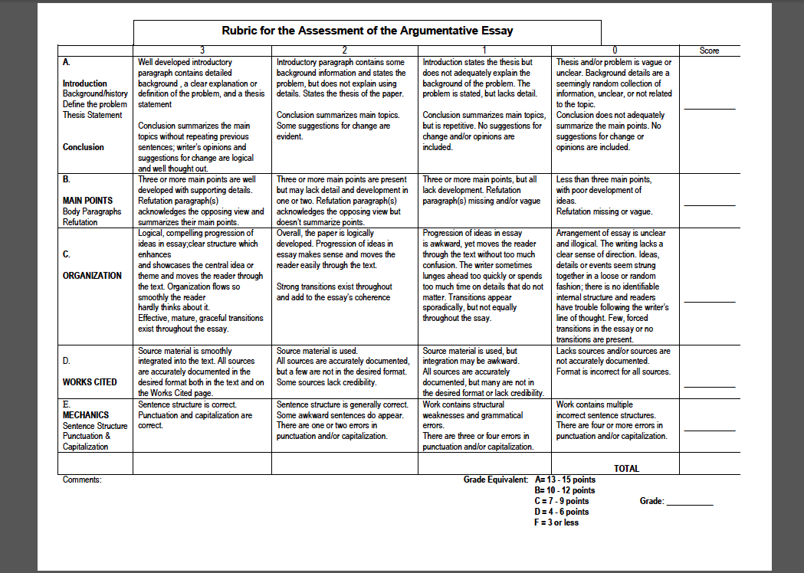

Standards:
ELAGSE9-10RL1: Cite strong and thorough textual evidence to support analysis of what the text says explicitly as well as inferences drawn from the text.
ELAGSE9-10W1: Write arguments to support claims in an analysis of substantive topics or texts, using valid reasoning and relevant and sufficient evidence.
a. Introduce precise claim(s), distinguish the claim(s) from alternate or opposing claims, and create an organization that establishes clear relationships among claim(s), counterclaims, reasons, and evidence.
b. Develop claim(s) and counterclaims fairly, supplying evidence for each while pointing out the strengths and limitations of both in a manner that anticipates the audience’s knowledge level and concerns.
c. Use words, phrases, and clauses to link the major sections of the text, create cohesion, and clarify the relationships between claim(s) and reasons, between reasons and evidence, and between claim(s) and counterclaims.
d. Establish and maintain an appropriate style and objective tone.
e. Provide a concluding statement or section that follows from and supports the argument presented.
LAGSE9-10W4: Produce clear and coherent writing in which the development, organization, and style are appropriate to task, purpose, and audience. (Grade-specific expectations for writing types are defined in standards 1–3 above.)
ELAGSE9-10W5: Develop and strengthen writing as needed by planning, revising, editing, rewriting, or trying a new approach, focusing on addressing what is most significant for a specific purpose and audience. (Editing for conventions should demonstrate command of Language standards 1–3 up to and including grades 9–10.)
ELAGSE9-10W6: Use technology, including the Internet, to produce, publish, and update individual or shared writing products, taking advantage of technology’s capacity to link to other information and to display information flexibly and dynamically.
ELAGSE9-10L1: Demonstrate command of the conventions of standard English grammar and usage when writing or speaking.
a. Use parallel structure.*
b. Use various types of phrases (noun, verb, adjectival, adverbial, participial, prepositional, absolute) and clauses (independent, dependent; noun, relative, adverbial) to convey specific meanings and add variety and interest to writing or presentations.
ELAGSE9-10L2: Demonstrate command of the conventions of standard English capitalization, punctuation, and spelling when writing.
a. Use a semicolon (and perhaps a conjunctive adverb) to link two or more closely related independent clauses.
b. Use a colon to introduce a list or quotation.
c. Spell correctly.
d. Produces legible work that shows accurate spelling and correct use of the conventions of punctuation and capitalization.
Works Cited

"Georgia Performance Standards (GPS)." Georgia Performance Standards (GPS). Web. 17 July 2015.

"Programs in International Educational Resources." Programs in International Educational Resources.
Web. 17 July 2015.

